35.51: First we need to find the angles at which the intensity drops by one-half from the value of the th bright fringe.
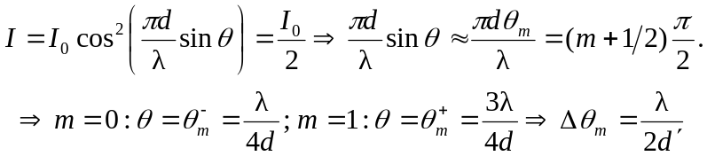
so there is no dependence on the value of the fringe.

